Project Overview

Project FORESIGHT is an end-to-end retail analytics and demand forecasting solution designed to transform sales and inventory data into actionable business insights. The project analyses revenue, sales performance, product and category performance, inventory levels, stockout and overstock risks, promotional effectiveness, seasonality, and demand forecasts. Using Python, SQL, and Power BI, FORESIGHT provides interactive dashboards and executive recommendations that help businesses make data-driven decisions around demand planning, inventory optimization, promotions, pricing, and store performance.

Business Problem

Retail businesses generate large volumes of sales, inventory, pricing, promotion, and demand data, but analysing these areas separately can make it difficult to identify operational risks and opportunities. Key challenges include maintaining the right inventory levels, reducing stockouts and excess inventory, understanding differences in store and product performance, evaluating promotional effectiveness, identifying seasonal demand patterns, and accurately forecasting future demand.
Project FORESIGHT addresses these challenges by integrating retail data analysis across sales, inventory, promotions, seasonality, and forecasting into a unified business intelligence solution. The project is designed to help decision-makers identify performance gaps, optimize inventory, understand demand patterns, and take data-driven actions.

Project Objectives

1. Analyse sales performance across stores, products, categories, price bands, and time periods.
2. Monitor inventory levels and identify low-stock and overstock conditions.
3. Identify stockout risks and support proactive inventory replenishment.
4. Identify excess inventory and recommend actions to reduce inventory holding.
5. Evaluate promotional performance and understand the contribution of promotions to sales.
6. Analyse seasonality and demand patterns across months, days, stores, and price bands.
7. Forecast future demand and evaluate forecast accuracy.
8. Compare store and product performance to identify high- and low-performing areas.
9. Develop interactive Power BI dashboards that allow users to explore business performance using filters and visual analytics.
10. Translate analytical findings into actionable business recommendations for inventory, pricing, promotions, forecasting, and store performance.

Dataset & Data Preparation

Dataset
Project FORESIGHT uses a retail sales and inventory dataset containing transactional, product, store, pricing, promotion, inventory, and demand-related information. The dataset covers multiple years of retail activity, with the dashboards providing analysis across 2022–2025.
Key fields and business dimensions used in the analysis include:
- store_id — identifies individual retail stores.
- sku_id — identifies individual products/SKUs.
- Date/Year — enables daily, monthly, quarterly, and yearly analysis.
- Price Band — categorizes products into Low Price, Mid Price, High Price, and Premium Price segments.
- Quantity — represents units sold.
- Revenue — represents sales generated.
- Discount Category — identifies different promotion/discount levels.
- Stock on Hand — represents available inventory.
- Reorder Point — supports inventory replenishment analysis.
- Stock Cover — measures the level of inventory coverage.
- Actual Demand — represents observed product demand.
- Forecast Demand — represents predicted demand used for forecasting analysis.
The dataset supports analysis across approximately 1 million transactions and 4K SKUs, with multiple stores and several years of historical data.

Data Preparation
The data was prepared before developing the Power BI dashboards to ensure that it could be used consistently for sales, inventory, forecasting, and business analysis.
The preparation process included:
- Reviewing the dataset structure and available fields.
- Ensuring appropriate data types for dates, numerical values, and categorical fields.
- Preparing date-related fields for year, month, quarter, and day-level analysis.
- Organizing product and store identifiers for comparative analysis.
- Preparing pricing and discount categories for pricing and promotion analysis.
- Preparing inventory-related fields such as stock on hand, reorder point, and stock cover.
- Preparing actual and forecast demand fields for forecasting analysis.
- Creating calculated measures required for KPIs such as revenue, quantity sold, average order value, revenue per unit, stockout rate, inventory value, excess inventory value, promotion sales percentage, and forecast accuracy.
- Structuring the prepared data for interactive analysis in Power BI using slicers, measures, and visualizations.
The prepared dataset was then used across the Sales, Product, Category, Inventory, Stockout Risk, Overstock, Promotion, Seasonality, Forecast, Business Insights, and Executive Recommendation dashboards.

Technology Stack

Project FORESIGHT was developed using the following technologies and tools:
- Python — Used for data preparation, data processing, feature engineering, and demand-related analysis.
- SQL / PostgreSQL — Used for querying, aggregating, and analysing retail sales and business data.
- Power BI — Used to build the interactive dashboards, KPIs, visual analytics, forecasting analysis, and executive recommendations.
- DAX (Data Analysis Expressions) — Used to create calculated measures and business KPIs within Power BI.
- Power Query — Used for data transformation, preparation, and creation of supporting tables such as the calendar/date dimension.
- Microsoft Excel / CSV — Used as data/file formats where applicable for handling and transferring datasets.

Data Model & Architecture
Project FORESIGHT uses a structured Power BI data model to connect retail sales data with supporting dimensions and enable consistent analysis across different business areas.
The primary sales and transaction data is maintained in the FactSales table. Supporting information is organized through dimension tables, including the DimDate calendar table and other relevant categorical dimensions used for product, store, pricing, and business analysis.
Key components of the data model
- FactSales — Contains the core retail sales and transaction-level data used for revenue, quantity, promotion, and demand analysis.
- DimDate — Provides the date hierarchy required for daily, monthly, quarterly, yearly, and seasonal analysis.
- Store-related fields — Enable store-level revenue, demand, inventory, and risk analysis.
- Product/SKU fields — Enable product-level sales, inventory, pricing, and overstock/stockout analysis.
- Price Band and promotion fields — Enable pricing and promotional performance analysis.
The DimDate table provides a consistent time dimension for the Power BI report and supports time-based calculations such as monthly, quarterly, yearly, and seasonal analysis.
The model supports interactive filtering through slicers such as Year, store_id, and Price Band, allowing users to analyse the same business metrics across different segments.

Data Flow

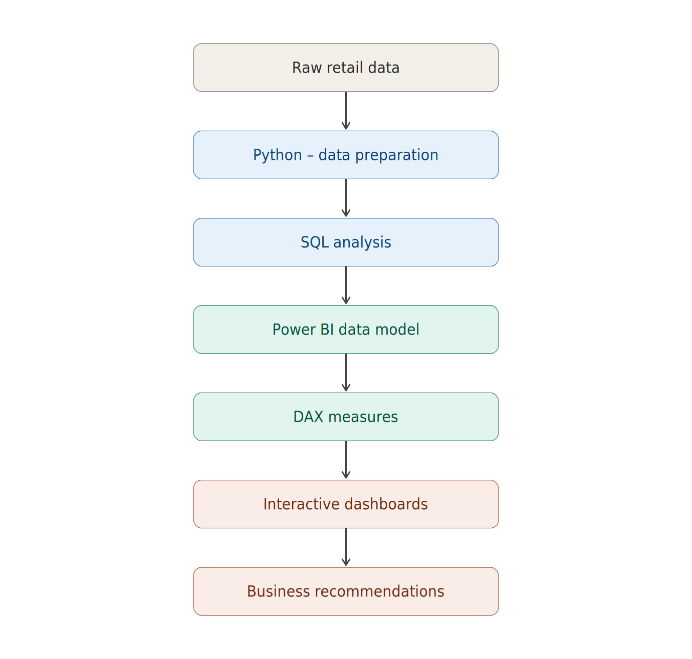
Python / Data Processing

Python was used as part of the data preparation and analytical workflow for Project FORESIGHT. The Python workflow supported data processing, feature preparation, and demand-related analysis before the data was used for SQL analysis and Power BI reporting.
The Python processing included preparing the retail dataset, organizing relevant analytical fields, and creating features required for demand and inventory analysis. These prepared fields supported subsequent calculations related to demand trends, rolling demand, demand volatility, and forecasting.
Python helped establish a structured and analysis-ready dataset that could then be queried using SQL and integrated into the Power BI data model.
Python Analysis Workflow
- Loaded and inspected the retail dataset.
- Reviewed data structure, columns, and data types.
- Prepared data for downstream SQL and Power BI analysis.
- Created and prepared demand-related analytical features.
- Supported rolling demand and volatility calculations.
- Prepared actual and forecast demand information for forecasting analysis.
- Exported the prepared data for further analysis and visualization.

SQL Analysis

PostgreSQL was used to perform structured analysis of the retail dataset and to derive business-level metrics required for the FORESIGHT reporting layer. SQL queries were used to aggregate, filter, and analyse sales, revenue, inventory, customer/store, and risk-related information.
The SQL analysis helped validate business metrics and provided a foundation for the Power BI dashboards. Queries were organized around portfolio-level analysis, risk analysis, customer-related analysis where applicable, and KPI calculations.

SQL Analysis Workflow
- Loaded the prepared retail data into PostgreSQL.
- Used SQL queries to aggregate and analyze business data.
- Calculated key sales and revenue metrics.
- Analyzed performance across stores, products, categories, and other business segments.
- Performed inventory and risk-related analysis.
- Created KPI-level queries to support dashboard development.
- Used SQL outputs to validate metrics used in Power BI.
- Connected the analytical results to the broader Python → SQL → Power BI workflow.

Power BI & DAX

Microsoft Power BI was used as the primary business intelligence and visualization platform for Project FORESIGHT. The prepared retail data was modeled in Power BI and transformed into interactive dashboards covering sales, products, categories, inventory, stockout risk, overstock, promotions, seasonality, forecasting, business insights, and executive recommendations.
DAX (Data Analysis Expressions) was used to create business measures and KPIs required for the analysis. These measures enabled dynamic calculations that responded to user selections and slicers.

Key DAX Measures & KPIs
- Total Revenue — measures overall sales revenue.
- Total Units Sold — measures total quantity sold.
- Total Transactions — measures transaction volume.
- Average Order Value (AOV) — measures average revenue generated per transaction.
- Revenue per Unit — measures revenue generated per unit sold.
- Average Discount — measures the average discount applied.
- Promotion Sales % — measures the contribution of promotional sales.
- Stockout Rate — measures the proportion of sales/inventory situations associated with stockout conditions.
- Stockout Risk % — identifies the proportion of inventory exposed to stockout risk.
- Inventory Value — measures the value of inventory held.
- Excess Inventory Value — measures inventory identified as excess/overstock.
- Forecast Demand — represents expected future demand.
- Forecast Accuracy % — evaluates the accuracy of forecast demand against actual demand.
- Forecast Error — measures the difference between actual and forecast demand.

Power BI Features Used
- Interactive slicers for filtering analysis.
- KPI cards for high-level business metrics.
- Time-series visualizations for revenue, demand, and forecast analysis.
- Bar and column charts for store, product, category, and price-band comparisons.
- Risk-focused visualizations for stockout and overstock analysis.
- Interactive filtering and cross-highlighting between visuals.
- Consistent dashboard formatting and navigation across the 12-page report.
Dashboard Architecture
The Power BI report consists of 12 analytical dashboards:
- Executive Business Intelligence
- Sales Analytics
- Product Performance
- Category Performance
- Inventory
- Stockout Risk
- Overstock
- Promotion
- Seasonality
- Forecast
- Business Insights
- Executive Recommendations
This structure allows FORESIGHT to move from high-level business performance → detailed analysis → forecasting → actionable recommendations.

Dashboard Architecture

Project FORESIGHT consists of 12 interconnected Power BI dashboards. Each dashboard focuses on a specific business area while contributing to the overall retail analytics and decision-making framework.
1. Executive Dashboard
Provides a high-level overview of overall business performance using revenue, transactions, units sold, AOV, inventory, and stockout-risk KPIs.
2. Sales Analytics Dashboard
Analysis revenue and sales performance across time, stores, products, and relevant business segments to identify sales trends and performance patterns.
3. Product Performance Dashboard
Evaluates individual product/SKU performance using sales, revenue, demand, and other product-level metrics to identify strong and weak performers.
4. Category Performance Dashboard
Compares performance across product categories to identify categories contributing most significantly to sales and revenue.
5. Inventory Dashboard
Provides visibility into inventory levels, inventory value, stock coverage, and other inventory-related KPIs to support inventory planning.
6. Stockout Risk Dashboard
Identifies products and stores exposed to stockout conditions and helps prioritize replenishment activities.
7. Overstock Dashboard
Identifies excess inventory, overstocked SKUs, inventory value, excess inventory value, and stock-cover conditions to support inventory reduction decisions.
8. Promotion Dashboard
Analysis promotional sales, discount performance, promotion contribution, and revenue differences to evaluate promotional effectiveness.
9. Seasonality Dashboard
Analysis historical sales and demand patterns across time to identify seasonal trends and recurring business patterns.
10. Forecast Dashboard
Compares actual demand with forecast demand and evaluates forecast accuracy and forecast error across time, stores, and price bands.
11. Business Insights Dashboard
Combines important business KPIs and comparative analyses to provide management with a broader view of revenue, transactions, AOV, discounts, stores, and price-band performance.
12. Executive Recommendation Dashboard
Converts analytical findings into actionable recommendations covering forecasting, stockout risk, overstock, promotions, revenue, store performance, and inventory optimization.
Overall Dashboard Flow
The dashboards follow a decision-making progression:
Executive Overview → Sales & Performance Analysis → Inventory & Risk Analysis → Promotion & Seasonality → Forecasting → Business Insights → Executive Recommendations
This structure allows users to move from understanding what is happening to identifying why it is happening and ultimately determining what action should be taken.

Key Business Insights

The analysis performed through Project FORESIGHT generated several important business insights across sales, inventory, promotions, forecasting, and store performance.
1. Strong Overall Revenue Performance
The Executive Dashboard reports approximately ₹1.51 billion in total revenue, demonstrating significant overall sales activity across the analyzed retail network.
2. High Forecast Accuracy
The Forecast Dashboard reports approximately 99.76% forecast accuracy. This indicates that the current forecasting approach closely reflects observed demand and can provide useful support for inventory planning.
3. Significant Stockout Exposure
The analysis identifies approximately 2K low-stock SKUs, while the Stockout Dashboard reports a 6.80% stockout rate. This indicates that inventory availability remains an important operational consideration.
4. Significant Excess Inventory
The Overstock Dashboard identifies approximately 3K overstock SKUs and approximately ₹5.94 billion in excess inventory value. This indicates that a substantial amount of capital may be tied up in excess inventory and requires active inventory optimization.
5. Promotions Have a Meaningful Sales Contribution
Promotional sales account for approximately 19.99% of total sales. This indicates that promotions represent a significant component of the overall sales mix and should be evaluated based on their effectiveness and return.
6. Store Performance Varies
Revenue analysis shows differences in performance across individual stores. This indicates an opportunity to investigate lower-performing stores and identify operational practices from stronger-performing locations.
7. Revenue Varies Across Price Bands
The analysis shows differences in revenue contribution across price bands. This provides an opportunity to evaluate pricing and product-mix strategies and focus on segments that generate stronger business performance.
8. Inventory Optimization Requires Balancing Multiple Signals
The combination of stockout risk, low-stock conditions, overstock levels, stock cover, and forecast demand demonstrates that inventory decisions should not rely on a single metric. A balanced approach is required to maintain product availability while reducing excess inventory.

Recommendations

Based on the findings generated through Project FORESIGHT, the following actions are recommended:
1. Forecast-Driven Inventory Planning — High Priority
Use forecast demand to support inventory planning and replenishment decisions, taking advantage of the high forecast accuracy observed in the analysis.
2. Stockout Risk Management — High Priority
Prioritize replenishment for products and stores exposed to higher stockout risk in order to improve product availability and reduce potential lost sales.
3. Overstock Reduction — High Priority
Reduce replenishment for overstocked SKUs and use targeted markdowns or promotions to clear excess inventory and release capital tied up in surplus stock.
4. Promotion Optimization — Medium Priority
Evaluate promotional campaigns based on their sales contribution and effectiveness, and prioritize campaigns that demonstrate stronger performance.
5. Pricing Optimization — Medium Priority
Focus on high-performing price bands and continuously evaluate pricing and product-mix strategies to improve revenue performance.
6. Store Performance Improvement — Medium Priority
Investigate lower-performing stores and identify successful practices from high-performing stores that can potentially be replicated across the retail network.
7. Integrated Inventory Optimization — High Priority
Balance inventory using forecast demand, stockout risk, overstock indicators, and stock-cover metrics rather than relying on a single inventory measure.

Business Impact

Project FORESIGHT provides a centralized analytical solution that enables management to make more informed, data-driven retail decisions.
The solution can create business value in the following areas:
1. Improved Demand Planning
High forecast accuracy provides a stronger basis for estimating future demand and planning inventory requirements.
2. Reduced Stockout Risk
Identifying low-stock products and higher-risk stores allows management to prioritize replenishment and potentially reduce lost sales caused by unavailable products.
3. Reduced Excess Inventory
Identifying overstocked SKUs and excess inventory value helps management reduce unnecessary inventory holdings and improve the use of working capital.
4. More Effective Promotions
Promotion analysis allows management to evaluate which promotional activities contribute meaningfully to sales and focus resources on more effective campaigns.
5. Better Pricing Decisions
Price-band analysis provides visibility into revenue performance across different pricing segments, supporting more informed pricing and product-mix decisions.
6. Improved Store Performance Management
Store-level analysis allows management to identify performance differences and investigate opportunities to improve lower-performing locations.
7. Faster Management Decision-Making
The interactive Power BI dashboards bring multiple business areas into a single analytical environment, allowing decision-makers to quickly move from high-level KPIs to detailed analysis and recommendations.

Overall Impact
FORESIGHT transforms raw retail data into a decision-support system that connects sales performance, inventory management, demand forecasting, promotions, and store performance. This enables management to identify risks earlier, allocate resources more effectively, and make data-driven operational decisions.

Limitations & Future Improvements

Although Project FORESIGHT provides a comprehensive retail analytics and decision-support solution, several areas could be enhanced in future iterations.
Limitations
- The forecasting analysis is based primarily on historical demand patterns and available retail data.
- External factors such as economic conditions, competitor pricing, weather, local events, and broader market trends are not incorporated.
- Forecast accuracy may vary when future demand patterns differ significantly from historical patterns.
- Promotion effectiveness is evaluated using available sales and promotion data; detailed campaign costs and profitability information may not be available.
- Inventory recommendations depend on the quality and completeness of stock, demand, and replenishment data.
- The current dashboards provide analytical recommendations but do not automatically execute inventory or pricing decisions.
Future Improvements
- Develop more advanced machine-learning forecasting models to capture complex demand patterns.
- Incorporate external variables such as weather, holidays, competitor pricing, and economic indicators.
- Add promotion ROI and campaign profitability analysis using detailed promotion-cost data.
- Implement automated alerts for high stockout risk and critical overstock conditions.
- Introduce SKU-level automated replenishment recommendations.
- Develop predictive models for stockout and overstock probability.
- Add scenario analysis to evaluate the potential impact of pricing, promotions, and inventory decisions.
- Automate data refresh and dashboard updates for near-real-time business monitoring.
- Integrate the solution with operational systems to support automated inventory and replenishment workflows.

